**RTL Diagram:**

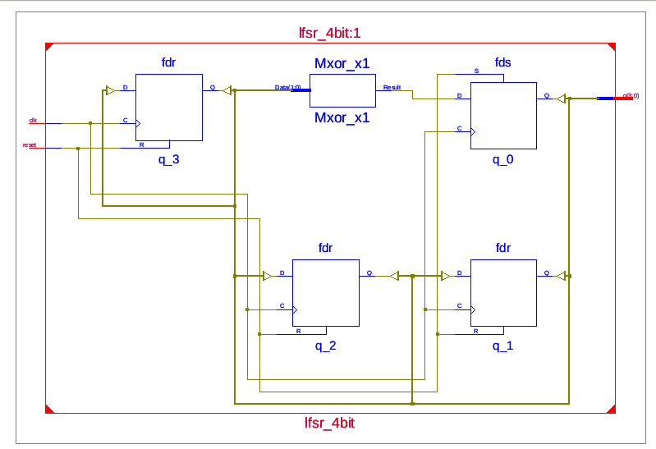

**Output Waveform:**

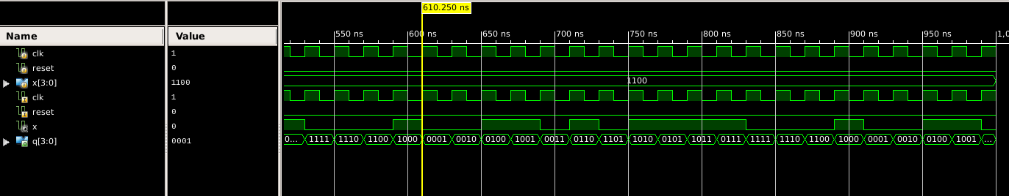

**Experiment-6**

**Objective:**

To design a LFSR. The test bench should check the generated output with the expected output.

**Tool Used:** Xilinx ISE.

**Theory:**

LFSRs (linear feedback shift registers) provide a simple means for generating nonsequential lists of numbers quickly on microcontrollers. Generating the pseudo-random numbers only requires a right-shift operation and an XOR operation.

**DUT Code:**

module lfsr_4bit(input clk, reset, output reg [3:0] q);

    wire x;

    assign x = q[3]^q[2];

    always@(posedge clk) begin

        if(reset) q <= 4'h1;

      else begin

            q[3] <= q[2];

            q[2] <= q[1];

            q[1] <= q[0];

            q[0] <= x;

        end

      end

endmodule

**TB Code:**

module tb;

  reg clk=0, reset;

  reg [3:0]x,q;

  lfsr_4bit uut (clk, reset, q);

  initial forever #10 clk=~clk;

  initial begin

    reset=1;

    #30 reset=0;

    #40;

    repeat(10) begin

      @(negedge clk)

      x=uut.q;

      x={x[2:0],x[3]^x[2]};

    end

    end

endmodule

**Result:**

The simulation output and the RTL diagram is observed and found to be valid.